Practical No 12
VIII. Resources required (Additional)
→ If any web resources required.

X. Resources used (Additional)
→ https://docs.microsoft.com/en-us/dotnet/api/system.windows.forms.tabcontrol
→ https://docs.microsoft.com/en-us/dotnet/api/system.timers.timer

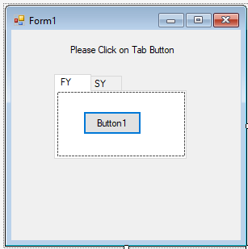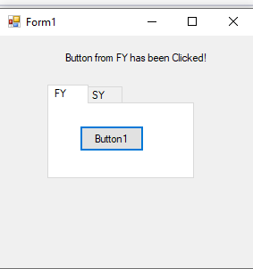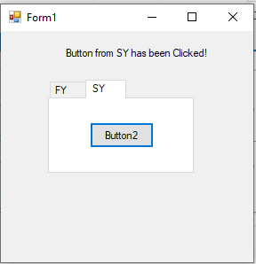
- Program Code
  - Write a program using Tab Control.
➢
Public Class Form1

Private Sub Button1_Click(sender As Object, e As EventArgs) Handles Button1.Click Label1.Text = "Button from FY has been Clicked!"
End Sub

Private Sub Button2_Click(sender As Object, e As EventArgs) Handles Button2.Click Label1.Text = "Button from SY has been Clicked!"
End Sub End Class
XII. Results (output of the program)

Practical related Questions
  - Write a procedure to display the icons on the Toolbar Control.
- ToolBar buttons are able to display icons within them for easy identification by users. This is achieved through adding images to the ImageList Component component and then associating the ImageList component with the ToolBar control.

To set an icon for a toolbar button programmatically

    - 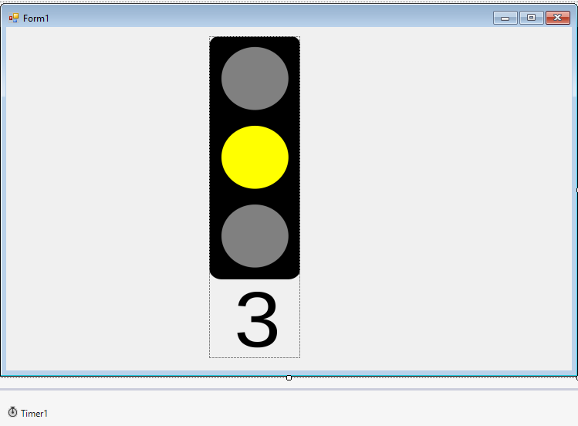In a procedure, instantiate an ImageList component and a ToolBar control.
    - In the same procedure, assign an image to the ImageList component.
    - In the same procedure, assign the ImageList control to the ToolBar control and assign the ImageIndex property of the individual toolbar buttons.

Difference between Form and Panel Control in VB.NET
- Windows Forms Panel controls are used to provide an identifiable grouping for other controls. Typically, you use panels to subdivide a form by function. The Panel control is similar to the GroupBox control; however, only the Panel control can have scroll bars, and only the GroupBox control displays a caption.

rcise
  - Write a program to display the traffic signal using timer control.

Public Class Form1

Private Sub Timer1_Tick(sender As Object, e As EventArgs) Handles Timer1.Tick If PictureBox1.Visible Then
PictureBox1.Visible = False PictureBox2.Visible = True PictureBox3.Visible = False ElseIf PictureBox2.Visible Then PictureBox1.Visible = False PictureBox2.Visible = False PictureBox3.Visible = True ElseIf PictureBox3.Visible Then

PictureBox1.Visible = True PictureBox2.Visible = False PictureBox3.Visible = False
End If End Sub

Private Sub Form1_Load(sender As Object, e As EventArgs) Handles MyBase.Load Timer1.Enabled = True
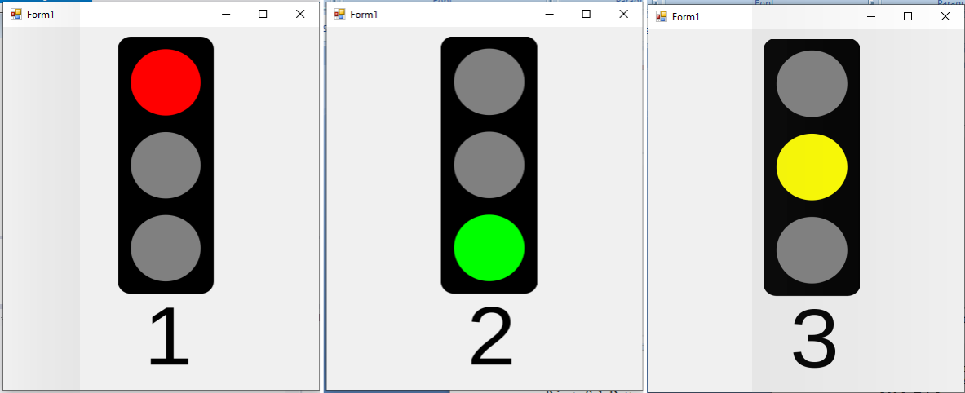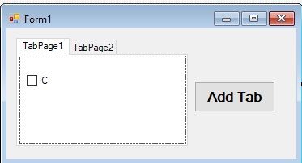Timer1.Interval = 1600 PictureBox1.Visible = True PictureBox2.Visible = False PictureBox3.Visible = False
End Sub

Private Sub PictureBox2_Click(sender As Object, e As EventArgs) Handles PictureBox2.Click

End Sub End Class

OUTPUT:

3. Write a program to demonstrate the Tab Control in VB.net.

Public Class Form1

Private Sub Form1_Load(sender As Object, e As EventArgs) Handles MyBase.Load TabPage1.Text = "FY"
TabPage2.Text = "SY" End Sub

Private Sub Button1_Click(sender As Object, e As EventArgs) Handles Button1.Click TabControl1.TabPages.Add("TY")
End Sub End Class

OUTPUT:

